SRS DOCUMENT FOR FRONTEND DEVELOPMENT – SPIDR

Objective:
- Design and Develop a dashboard application that can run locally in a browser
- The dashboard application should be able to
  - Run organ specific algorithm
  - Show plots and KPIs generated by the algorithm

- The dashboard application will have the following screens
  - Organ Selection Screen
    - SEQ file selection
  - Show the plots and KPIs
  - Any other screens as required for proper functioning

Context & Background:
- The backend algorithm runs in Python.
- The application will run in an air-gapped scenario inside an Operation Theatre. So, there will be almost no connectivity to the Internet during execution.
- The backend algorithm runs in two stages.

Stage 1: Segregation of Thermal stages. This will output a JSON file. An example file has been attached as STAGE_JSON
    - Input: Case number & .SEQ file location
    - Output: A JSON file
>> python /loc/to/stage_division_auto.py case_num full_address/to/seq_file/
python stage_division_auto.py 3 "I:\SPIDR\Live Experiment\Avi Cases\Case 3-Namita Bain-Test\Rec-1852.seq"
(base) C:\Users\Subhasish Sarkar>h:

(base) H:\>cd coding\spidr_stage_division

(base) H:\coding\spidr_stage_division>conda activate spidr1

(spidr1) H:\coding\spidr_stage_division> python .\stage_division_auto.py 20 "I:\SPIDR\Live Experiment\CT-20\Rec-2127.seq"
Stage 2: Data Transformation stage
    - Input: Case number, name of the JSON file generated in the previous stage.
    - Output: This stage will generate multiple files inside a subdirectory of the folder containing the. SEQ file
python run_processing_pipeline.py 3 "I:\SPIDR\Live Experiment\Avi Cases" stages_Rec-1852_0_4533_1765010865.json
H:\coding\spidr_stage_division>python "H:\coding\rate_explore_seq\run_processing_pipeline.py" 59 "D:\Python_test_run" stages_Rec-158_07_01_54_779-0158-IR_0_26360_1766214573.json

python "H:\coding\rate_explore_seq\run_processing_pipeline.py" 20 "I:\SPIDR\Live Experiment" stages_Rec-2127_0_4282_1766226174.json

Example
In the following figure, Rec-1852 is the. SEQ file. It is located inside a folder whose name starts with “CASE 1 ..”.

Before Stage1: The folder structure required to be as following.
Rec-1852.seq is the recorded video

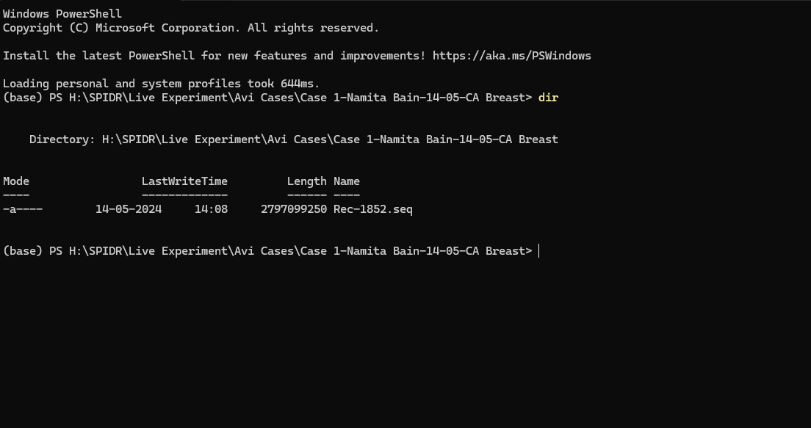

After Running Stage 1:

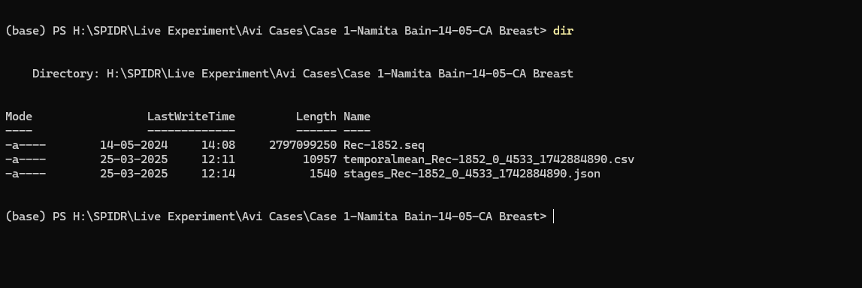

Two files are generated as shown above. The details of these files are as follows
      - stages_Rec-1852_0_4533_1742884890.json: This file contains details of various parameters extracted from the .SEQ file as required downstream. The filename contains few ready info separated by “_” as follows
        - stages : Denotes it is a stage file
        - Rec-1852 : Is the name of the recording that this stage file belongs to.
        - 0 : Initial frame number.
        - 4533 : The last frame number
        - 1742884890 : Epoch timestamp of when the file is generated.
      - temporalmean_Rec-1852_0_4533_1742884890.csv: This file contains the mean temperature of each frame calculated in this stage.

A sample JSON & CSV file has been attached

After Running Stage 2:
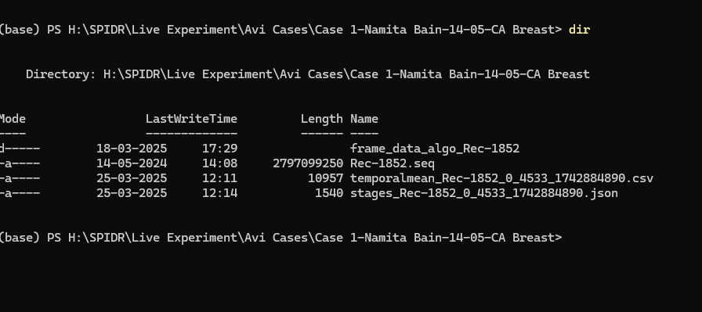

A new folder frame_data_algo_Rec-1852 has been generated. frame_data_algo will be common prefix for Recording that has been processed through Stage 2 Algo. The name of the recording will be appended to it. In this case Rec-1852 has been appended.
This is done because some cases can have multiple recordings. In such scenarios each SEQ file will have individual stages_ file and frame_data_algo folder
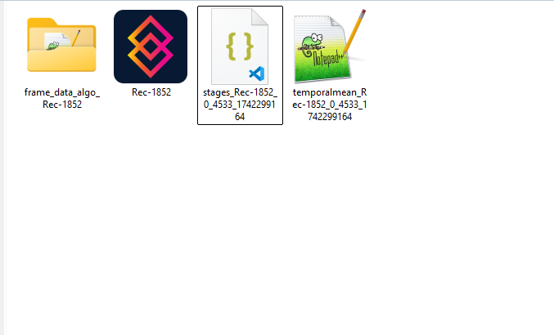

The contents of the Folder is as under:
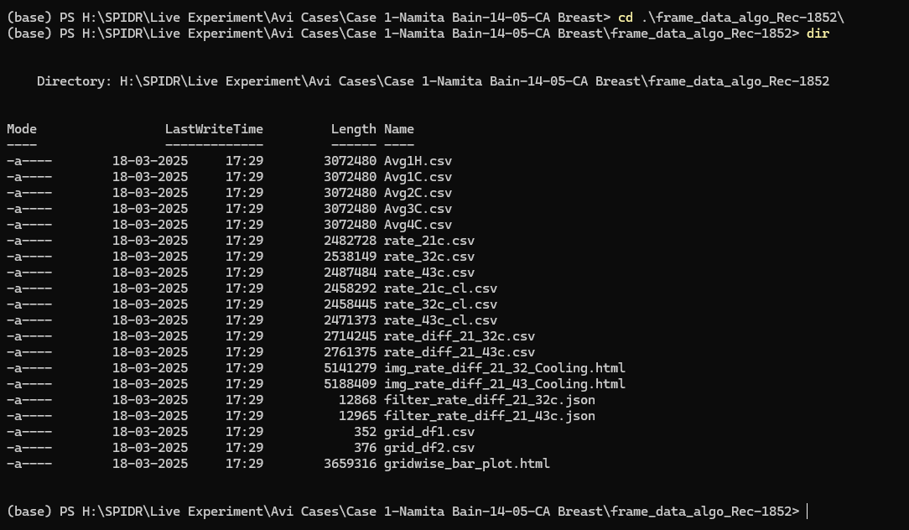

- The dashboard should show the
  - The case number, Organ name, date time, Seq file name
  - Three .html files. These are basically images
  - Few more KPIs. The KPIs are still under development. The data structure can be expected to be mostly a separate JSON file.

Performance Requirements:
- The application needs to have almost zero lag period as it will be used intra-operatively.
- The application needs to run locally without any internet connectivity

